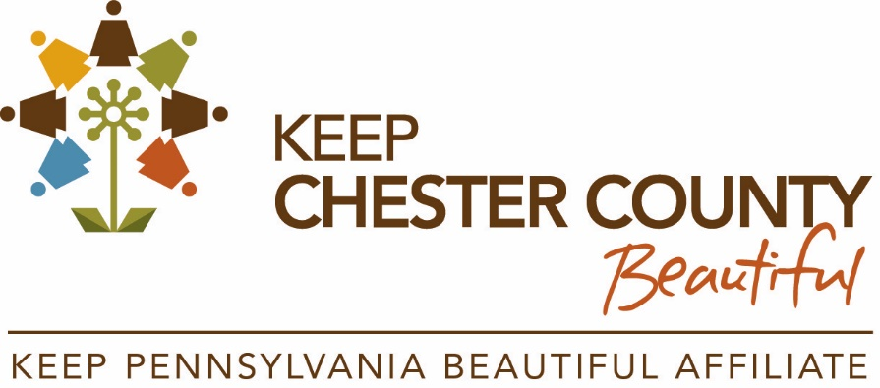

Litter Lifter How -To Guide - Partner Toolkit

Find Keep Chester County Beautiful on social media:
Facebook: @KeepChesterCountyBeautiful
Instagram: @KeepChesterCountyBeautiful
Twitter: @BeautifulChesco
Keep Chester County Beautiful and the Litter Lifters of West Vincent Township prepared a new guide to help groups through the steps of organizing a litter clean-up event – just in time for those looking to plan an event for Earth Day!
We encourage partners to share this guide to help groups get started. Below is sample language for sharing on your website, social media, and other communications.
FACEBOOK:
Planning an event for Earth Day but not sure where to start? @KeepChesterCountyBeautiful and the Litter Lifters of @WestVincentTwp released a new guide with steps for organizing a litter clean-up event in your community! Check it out to learn more: https://www.chescoplanning.org/Environmental/KCCB/programs.cfm#LitterLifter

INSTAGRAM:
Earth Day is right around the corner! If you’re thinking of planning a clean-up event in your community, check out @KeepChesterCountyBeautiful and @LitterLiftersofWestVincent’s new guide for instructions to help you get started. Visit ChescoPlanning.org to learn more.

TWITTER:
Planning an Earth Day clean-up event? @KeepChesterCountyBeautiful & @WestVincentTwp Litter Lifters released a guide with helpful instructions to plan your event! Check it out: https://www.chescoplanning.org/Environmental/KCCB/programs.cfm#LitterLifter

WEBSITES, EMAIL BLASTS, NEWSLETTERS, ETC.:
Keep Chester County Beautiful and the Litter Lifters of West Vincent Township released a new guide to help groups through the steps of organizing a litter clean-up event – just in time for those looking to plan an event for Earth Day! To start planning your event and view the guide, visit https://www.chescoplanning.org/Environmental/KCCB/programs.cfm#LitterLifter.

